C373 Final Assessment – Graded Assignment
Individual Roles and Responsibilities

There are Four Sections in this document. Do complete ALL Sections:
- Section 1: Project Declaration of Compliance
- Section 2: Individual Roles and Responsibilities Record
- Section 3: Individual Reflection
- Section 4: AI Interaction Journal
Note: Write succinctly this evidence-based report.

Section1: Project Declaration of Compliance

Student ID | 24046565
Student Name | Chow Sherwin
Class-Team | e.g. C002-Team4

Academic Integrity Compliance Statement
I declare that:
- This submission is my original work – all sources have been properly referenced and acknowledged.
- I have neither received nor rendered any assistance (either paid or unpaid) on work that requires individual effort.
- I have fully complied with the RP rules and regulations for students pertaining to assessments and academic integrity outlined here and

If found guilty of committing any act of academic dishonesty, I understand that I will be liable:
- for disciplinary action by the School
- to the full extent of penalties, including immediate failure for this assessment and other disciplinary actions such as dismissal
Retention of Backup Copy
I declare that I have a back-up electronic copy of this submission for immediate resubmission.
Digital Signature | Chow SHerwin | Date | 12/12/2025
IMPORTANT: Non-compliance to these clauses will result in unconditional rejection of your submission.

Section 2: Individual Role and Responsibilities Record

- Deliverable 1 [Team Prototype]: Evidence of your contributions to team’s Business Prototype.
<A brief description of what you did. Provide screenshot(s) if available>
Created whole figma , using figma ai under my account and share with the team .
prompted AI to create a website which suits able to track orders and reviews as the main issues were regarding trust , shipping transparency and reviews integrity
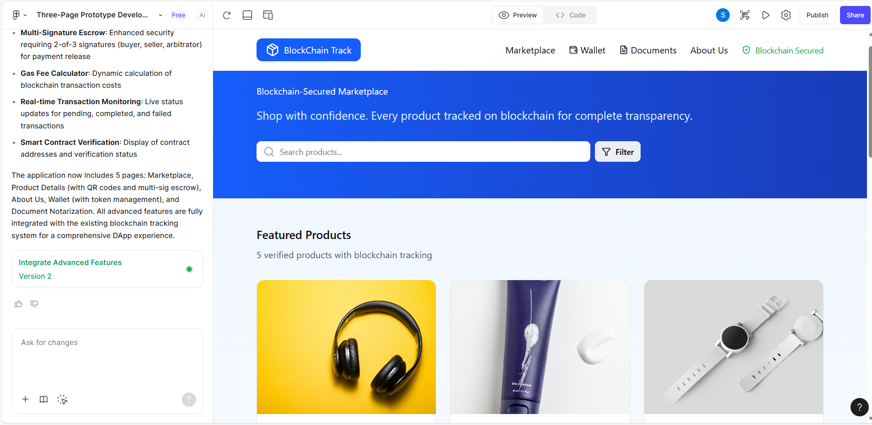

- Deliverable 2 [Team Report]:
  - Deliverable 2a [Team Report]: Evidence of your contributions to team’s Research.
<A brief description of what you did. Provide screenshot(s) if available>
Collaborated in the ‘how research influenced our design’
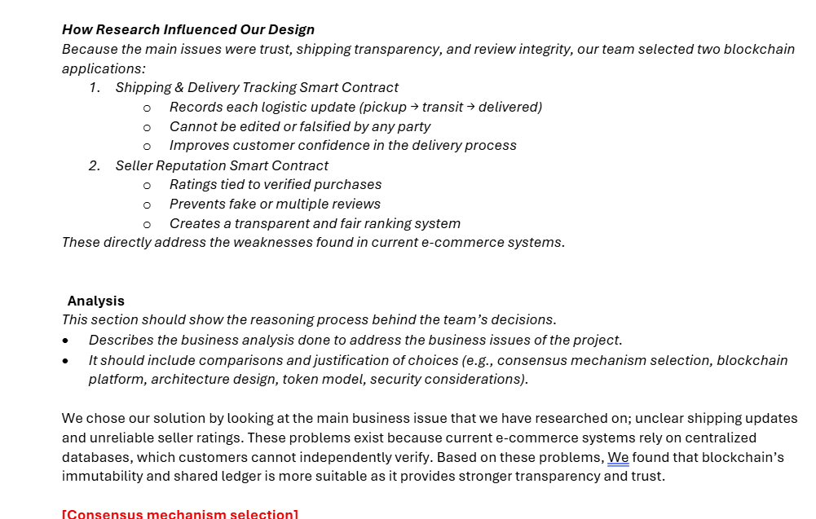

  - Deliverable 2b [Team Report]: Provide evidence of your contributions to team’s Analysis.
<A brief description of what you did. Provide screenshot(s) if available>
Did mention RBAC for security consideration part
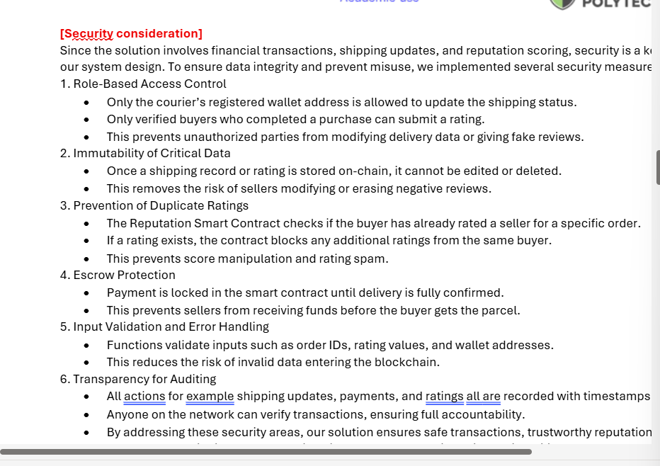

  - Deliverable 2c [Team Report]: Provide evidence of your contributions to team’s Discussions.
<A brief description of what you did. Provide screenshot(s) if available>
Suggested problem statement on ms teams and Prototype
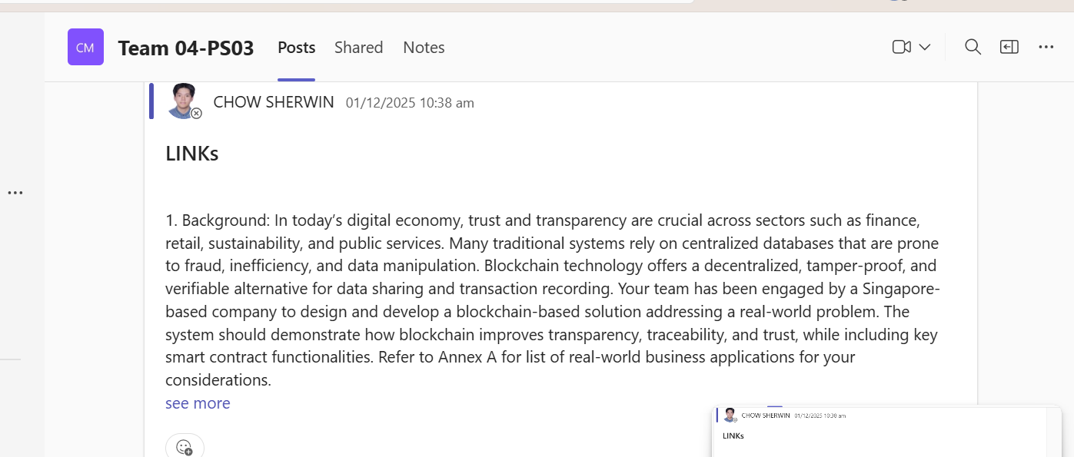
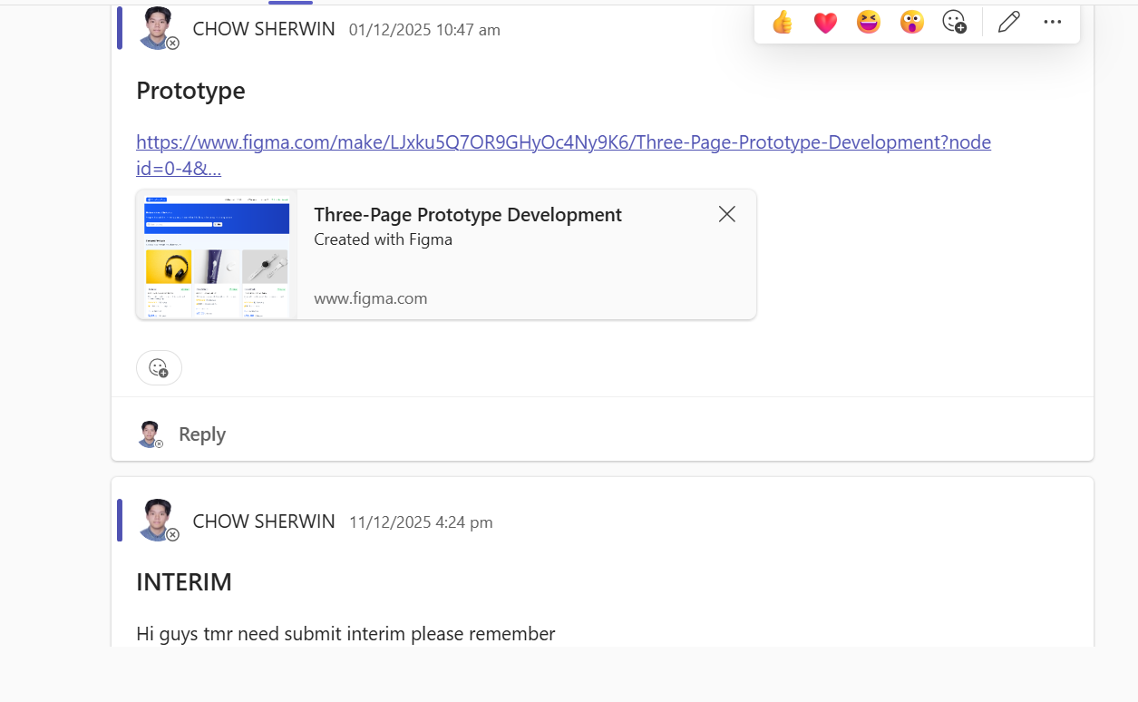

- Deliverable 3a: Team Project Codes – Functions and Test Cases

- List the full functions name in your smart contract that you have written including the parameters.
<List the function names. Provide screenshot(s) if available>
ReviewContract.sol
- submitReview(uint256 productId, bytes32 purchaseId, uint8 rating, string commentHash, bytes32 deliveryTxHash)
- getReviews(uint256 productId)
- getAverageRating(uint256 productId)
- hasReviewed(bytes32 purchaseId)
ReputationContract.sol
- constructor()
- rateSeller(address seller, bytes32 orderId, uint8 score, uint8 quality, uint8 shipping, uint8 communication)
- verifySeller(address seller, bool verified)
- addSales(address seller, uint256 increment)
- setSales(address seller, uint256 totalSales)
- getSellerReputation(address seller)
- getSellerDistribution(address seller)
- getRatings(address seller)
- hasRated(address seller, bytes32 orderId)
- _computeWeight(uint256 timestamp) (internal)
- _weightForBand(WeightBand band) (internal)
UserManagementContract.sol
- constructor()
- registerUser(address user)
- promoteToAdmin(address user)
- demoteToUser(address user)
- transferSuperAdmin(address newSuperAdmin)
- setStatus(address user, bool active)
- getUser(address user)
- _setRole(address user, Role role) (internal)
WalletContract.sol
- constructor()
- balanceOf(address account)
- topUp() payable
- mintCredit(address to, uint256 amount)
- transfer(address to, uint256 amount)
- createEscrow(bytes32 escrowId, address seller, uint256 amount)
- releaseEscrow(bytes32 escrowId)
- refundEscrow(bytes32 escrowId)
- quoteGas(uint256 gasUnits, uint256 gasPriceWei)
- currentGasPrice()
- getTransactionCount()
- getTransaction(uint256 txId)
- getAccountTransactions(address account)
- _recordTransaction(address from, address to, uint256 amount, TxType txType, bytes32 txReference) (internal)
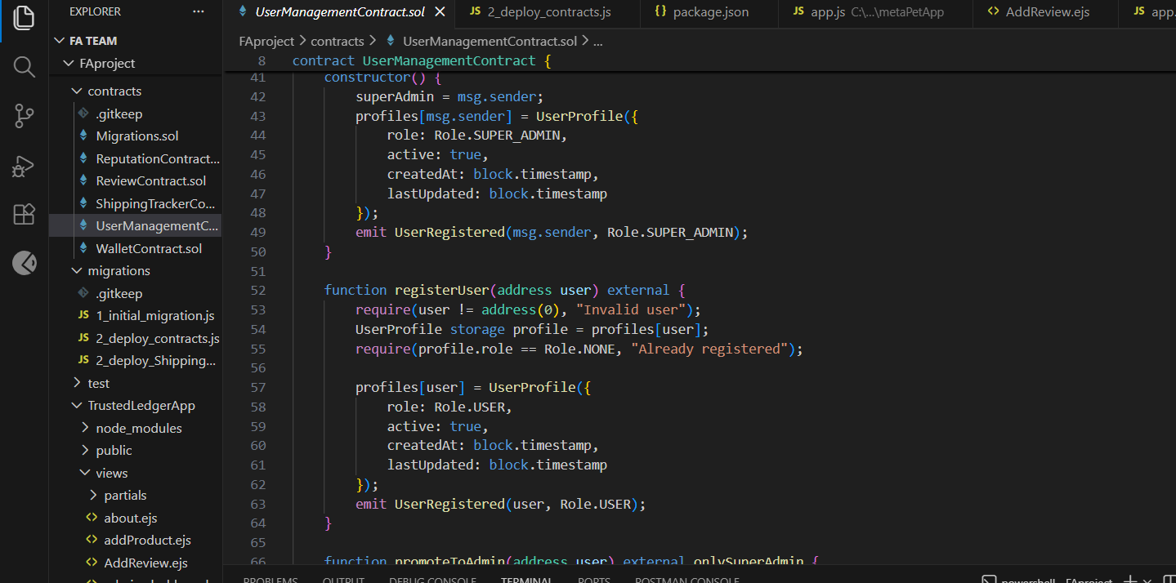

- List down the name of the test cases that you have written for your GA
<List the test cases names. Provide screenshot(s) if available>

- Provide any other evidence(s) of your coding contributions
<Describe briefly. Provide screenshot(s) if available>

- Deliverable 3b: Team Project Codes – Migration and Deployment

- Compile the smart contract (*.js). Provide evidence of the output of your project.
<Provide brief description of what you do. Provide screenshot(s) if available>

- Deploy and Migrate to the Testnet (Sepolia/Goerli etc)
< Provide brief description of what you do. Provide screenshot(s) if available>

- Provide any other evidence(s) of your migration and deployment contributions
<Describe briefly. Provide screenshot(s) if available>

Section 3: Individual Reflection

- Write succinctly (200-500 words only) reflection. Your discussion includes challenges faced and how you overcome them.

- Individual – Additional tasks performed individually e.g. Integration to wallet etc

<A brief description of what you did. Provide screenshot(s) if available>
- Smartcontracts: authored ReviewContract.sol, ReputationContract.sol, UserManagementContract.sol, and WalletContract.sol with full on-chain logic for reviews, weighted seller reputation, role/status registry, and custodial wallet + escrow (*.sol).
- Auth & session flows: built email/password login, admin login gating, registration, session storage, and route guards requireLogin / requireAdmin to protect wallet/admin pages (app.js).
- Wallet UX (mocked backend): created /wallet route that renders balances, token metadata, and transaction history for the user session (app.js).
- Product catalog & admin add flow: mock product data, product detail view, rating distribution, and an /addproduct form with validation + dynamic product creation (app.js).
- Shipping/Web3 integration: endpoints for MetaMask/web3 connection and shipment lifecycle—/web3Connect (load ABI, connect to contract, get shipment count), /shipments (list seller shipments), /createShipment, /track/:trackingId, /updateStatus/:trackingId, /confirmDelivery/:trackingId—including input validation and gas estimates (app.js).

Section 4: AI Interaction Journal
- Provide the prompts that you have executed during this assignment. DO NOT INCLUDE THE RESPONSES
- Declare the AI, LLMs tools/ URLs that you used
- For each prompt: Explain its usage and usefulness in your - research, analysis, coding, etc.

Format:
- Prompt Executed:
  - Tool used (URL if online):
  - Usage and usefulness:

- Prompt Executed:
  - Tool used (URL if online):
  - Usage and usefulness:

